COS 111: Computers and Computing
Spring 2005 Mid-Term Exam
03-09-2005
Maximum Time: 80 minutes.
6 questions. 80 points (not necessarily 1 point per minute).

Please read all questions before beginning to answer any one, and answer questions in the order that’s best for you.

We have tried to leave enough space for the answer to each sub-question just after that sub-question. If you need more space, please use the reverse sides of pages, and indicate where answers are continued on the reverse side.

Please write and sign the honor code below.

Question 1. Gates and Boolean Logic (6 points)

(a) We already know what a "universal" gate is. We proved that a NAND gate is Universal. We also know that AND, OR and NOT gates taken together are universal. There is also a concept of "minimal universal" gates. A set of universal gates is minimal universal if after removing any of the gates in the set, the set is no longer universal. For example, consider the AND, OR, NOT and NAND gates. Taken together they are universal, but they do not constitute a minimal universal set since the subset (AND, OR, NOT) by itself is universal, even without the NAND gate (and so is the NAND gate by itself). Thus, removing any one of AND, OR, NOT or NAND leaves a universal set, as does removing any two or three out of AND, OR or NOT.

A NAND gate is minimal universal. Is the group AND, OR, NOT a minimal universal group? Justify your answer.

Group is not minimal as AND and NOT gate can be combined to form a NAND gate. Hence, the OR gate can be eliminated. Alternately, NOT and OR can be combined to form NOR gate.

(b) Simplify the following Boolean expression: x + x'.y
[Note: this is the same as x OR ((NOT x) AND y), just in other notation]

Using universal method, the truth table is same as that of x OR y. Alternately,

X + X'.Y = (X + X').(X + Y) = (1).(X+Y) = X + Y

Question 2. Gates from other gates (8 points)

The NOR gate has the following truth table:

X Y || NOR(X,Y)
--------------------
0 0 || 1
0 1 || 0
1 0 || 0
1 1 || 0

You can draw a NOR gate as just a box with "NOR" written inside.

(a) Make a NOT gate out of a NOR gate(s). Recall that you can "hard wire" an input to a gate to always be 0 or always be 1.

NOT(x) = NOR(x,x)
NOT(x) = NOR(x,0)

(b) Make an AND gate out of NOR gates.

AND(x,y) = NOR(NOT x, NOT y)

(c) Make an OR gate out of NOR gates.

OR(x,y) = NOT(NOR(x,y))

Remember that once you have made any gate/circuit out of NOR gates, you can use it in making any other gates/circuits.
Question 3. Bigger Circuits from Smaller (10 points)

A de-multiplexer, as you might expect, does the opposite of a multiplexer. It is a logic device that lets you send out ("demultiplex") the value of an input channel (wire) over one of 2 or more output channels. By means of certain "selector lines," we can control which output channel is used to pass on the data in the input channel.

Consider the 1:2 demux (short for demultiplexer) below:

d0

in

1:2
d1

s

This device behaves as follows: 'd0' is equal to 'in' and 'd1' is equal to 0 when 's' is 0, and 'd1' is equal to 'in' and 'd0' is equal to 0 when 's' is 1.

(a) Construct a truth table for this device ('in', 's' are the inputs and 'd0', 'd1' are the outputs). Draw a logic diagram for the device using AND, OR and NOT gates.

d0 = (NOT s) AND in
d1 = s AND in

The truth table and logic diagram follow from above.

(b) A 1:4 demux has 4 outputs and (as usual) 1 input. However, there are 2 select lines 's0', and 's1,' which help choose one of the four outputs. i.e.,

For s1=0 and s0=0, d0 = in (the rest of the output lines are 0).
For s1=0 and s0=1, d1 = in (the rest of the output lines are 0).
For s1=1 and s0=0, d2 = in (the rest of the output lines are 0).
For s1=1 and s0=1, d3 = in (the rest of the output lines are 0).

Your task now is to construct a 1:4 demux using three 1:2 demuxes. Show your result below.

d0
d3
d1
d2
in
s0
s1

(c) How many 1:2 demuxes will you need to make a 1:8 demux ? Just the number: no need to show what it looks like.

7
Question 4. State Machines (24 points)

[Note: This question does not ask you to build actual logic circuits out of gates, do the detailed work of actually constructing truth tables or logic circuits. Rather, you need to do the high-level work of figuring out what states, inputs, and transition rules are needed. So please take your time to think through the situation and your design of states and inputs.]

Digital radio tuners have a simple controller inside them, to tune the radio to a specific frequency. You have to design one such simplified controller. Assume it is only for the FM band (88 - 108 MHz) and that FM stations are in odd slots separated by 0.2 MHz (i.e., 88.1, 88.3, 88.5, ... 107.9, for a total of 100 stations). Assume, if it helps simplify your work, that whenever the controller is powered on, it starts out set at 88.1 MHz (i.e. the first station). The controller's user interface allows a user to press a "<" or ">" button to go to the previous or next station, respectively. i.e., if you are tuned to 93.7 and you press >, you go to 93.9 and if you press <, you go to 93.5). The output of the controller at any time is the station that it is currently set to, but without the decimal point. That is, if you are tuned to 97.5, the output of the controller is 975.

(In case you need it, decimal 100 in binary is 1100100, 881 is 1101110001 and 1079 is 110111000110000110111. It is, however, acceptable to simply use decimal numbers 100, 881, etc where its only a matter of representation and doesn't make any difference to the logic.)

(a)
i) What are the states of the controller state machine? What does the state transition diagram look like (you don’t have to draw the entire diagram. You can describe it in words or convey it with the help of words and a diagram etc.)? How are you going to represent the states in memory?

The state machine has 100 states with each state corresponding to a station in the FM band. For simplicity, we can represent the state by the number corresponding to the station the controller is set to. The diagram for the state machine will look like –

881
883
1077
1079
“>”
“>”
“<”
“<”
“>”
“<”
. . .

ii) What are the inputs to the logic part of the state machine? What does the logic part do? (Again, just describe in words here.)

The inputs to the logic part are the current station, and an input i indicating which of the buttons was pressed (0 for >, 1 for <). Since it is not really practical to describe what the logic part will do using the universal method (the table will have 200 lines), we can describe its internals.

Note: all adders, subtracters, multiplexers etc operate on 11-bit values as 1079 needs 11-bits.

The current station value is fed to an adder and a subtracter (in parallel), which add 2 and subtract 2 respectively. Now the next station needs to be picked depending upon whether the “>” button or the “<” button was pressed. The output of the adder and subtracter is therefore fed, as inputs, to a 2:1 multiplexer whose controlling line (s) is the input i. The output of the multiplexer is both the output of the controller (the new station) as well as fed back to the memory to be stored.

The above doesn’t address the problem of end conditions. Pressing a “>” on 1079 is supposed to keep the output at 1079 instead of going to 1081. Similarly for 881 and pressing “<”.

Let us look at the first case. In order to prevent the controller from going over 1079, we need a correcting stage after adding 2 to the current station but before feeding it to the multiplexer. The correcting stage works as follows – it compares the input to 1081. If the input is 1081, the output is set to 1079. Otherwise the output is same as input.
The 2nd part of the correcting stage (picking whether to output 1079 or the input) can be done with a multiplexer as before (with the control line s being supplied by the result of the comparing part). To build an 11-bit comparator, we need to first build a 1-bit comparator. A comparator will output 1 whenever both outputs are same, i.e., both are 0 or both are 1. This is exactly opposite of a XOR (Exclusive-OR) gate. To build a multi-bit comparator, we simply take the AND of the output of each individual 1-bit comparator.

We can similarly take care of the case where the “<” button is pressed when the controller is at 881 by building a correcting stage after subtracting 2 but before feeding the result to the multiplexer.

Note: I didn’t mention anything about the clock to the controller or what happens when the user presses both > and < buttons at the same time. The reason was that the presence of clock is required but doesn’t change anything in the working of the controller which is our focus. And the case where user presses both is something that can be handled outside the working of the controller – we want things to happen when user presses one of the buttons and nothing otherwise. When such situations arise, the clock signal is ANDed with the condition when we want stuff to happen before being fed to the state machine. Hence, whenever the don’t-do-anything condition arises (the opposite of when we want stuff to happen), it cuts off the clock to the state machine (if one input to AND gate is 0, the output is always 0) and nothing happens. In this case, the clock is ANDed with XOR of > and < lines. Hence the clock will be effective only when 1 and only 1 of the 2 buttons is pressed.

Note2: If you wondering how input i is derived from buttons > and <,
i can be XOR(>, <) AND > or it can be XOR(>,<) AND < depending upon how the connections to the multiplexer are made.

Note3: This is by no means the most efficient design. Far from it in fact but its correct and quick to construct.

iii) Draw the complete state machine. You don't have to draw the state diagram or show transition rules or draw the truth table. You only have to show the block diagram with the memory and the logic portion. While drawing the logic part, you don't have to show internals of circuits that you have already seen in class or in assignments. For example, if you want to use an 8-bit adder, you can just draw a box and write "8-bit adder" in it, since you have already seen a ripple carry adder and know how to put 1-bit adders together to make an adder of any size. Similarly, you can just a draw box and write 10-bit (or whatever size you use) memory register on it without worrying about its internals.

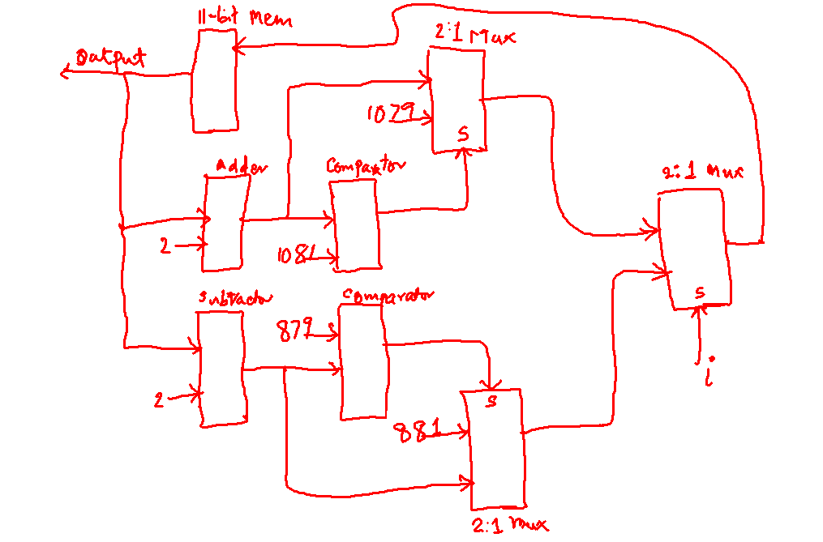

(b) Suppose you want to add a small convenience feature to the controller. You want the > and < buttons to wrap around. i.e., if you are tuned to 107.9 (the last station) and you press >, the controller goes to 88.1 (the first station) instead of not going further or going to the undefined station 108.1. Similarly on pressing < on 88.1, you go to 107.9.

How will adding this feature to the controller change your state machine? You don't have to draw the new state machine. You can say in words how this will change the machine. Try to be precise and clear in your answer. First say what changes, if any, will be needed in the state transition diagram; i.e., mention any new states and new transitions that might be needed. Then describe what changes take place in the memory part and in the logic part of the state machine. This stage-by-stage answer will help you describe your approach and answer. Note that if we don't follow what you are trying to say, you won't get credit for your work.

Adding the wrap around feature changes the state transition diagram only at the ends. The transition from 881 to itself on < becomes a transition to 1079. Similarly, the transition from 1079 on > onto itself becomes a transition to 881.

For the logic part, the change is rather simple. In the correcting stages, swap the values of 1079 and 881 being fed to the multiplexers.

Question 5. Circuits from Truth Tables (8 points)

Draw a circuit using AND, OR, and NOT gates for the truth table below, using the universal method discussed in class.

Note, when drawing, don't worry too much about making your pictures look good. Just be sure to write inside each gate what type of gate it is (like in the lecture).

W X Y || Z
----------------
0 0 0 || 1
0 0 1 || 0
0 1 0 || 0
0 1 1 || 1
1 0 0 || 1
1 0 1 || 0
1 1 0 || 0
1 1 1 || 1

AND
AND
AND
AND
OR
W
X
Y

FOR EXTRA CREDIT: Can you simplify this circuit ?

Simplified circuit is that of X.Y + X'.Y'
Question 6. Assembly Language Programming (24 points)

(a) Using the instructions that you learned about in class, write an assembly language program that does the following. The program assumes that N data values are stored sequentially in memory starting at location 1500. It treats these numbers as belonging to two sequences: the even numbered sequence is the sequence that starts at the first of these data items (think of it as data item number 0) and includes every alternate data value after
it (so data items 2, 4, 6 and so on); the odd numbered sequence is the sequence that starts at the second of these data items (think of it as data item number 1) and includes every alternate data value after it (so data items 3, 5, 7 and so on). When the program halts:

- The value left in the variable "even_less" in memory is the number of data items in the even numbered sequence that are smaller than 100,
- The value left in the variable "even_more" in memory is the number of data items in the even numbered sequence that are greater than or equal to 100,
- The value left in the variable "odd_less" in memory is the number of data items in the odd numbered sequence that are smaller than 100,
- The value left in the variable "odd_more" in memory is the number of data items in the odd numbered sequence that are greater than or equal to 100.

Write your program using as few registers and as few instructions as you reasonably can. Remember, though, that getting it correct carries more points than the additional points gained from making it efficient. Feel free to write a simple but correct program first and then attempt to write another one that is more optimized.

You should be able to write this program with the simple instructions we considered such as ADD, SUBTRACT, LOAD, LOAD-DIRECT, STORE, STORE-DIRECT, JUMP-IF-POSITIVE, HALT etc.

More points will be given to those who are able to write actual assembly language instructions throughout and implement the program using only actual assembly language instructions, e.g. "JUMP-IF-POSITIVE r2 1005". If you cannot remember exact assembly instructions, however, try to get as close to them as possible and use any representations that convey the point if necessary. It is better to use higher-level 'pseudo-code" (such as "if" statements etc) where necessary than to not attempt an answer at all. Note that you do not have to remember or use values like 1, 2, etc for Opcodes; rather, you can use mnemonic representations like ADD R1 <-- R2 + R3 and

Note: You do not have to worry about the actual addresses of the variables even_less, even_more etc.

Hint: Recall what was discussed in class about the common practice of having one instruction put its result in register 0 and then using a certain type of JUMP instruction after it.

FOR EXTRA CREDIT: Describe in words what the following program does.
26: Load R2 ← 015E (input value)
25: Load R3 ← 014E (input value)
27: Load R1 ← N (input value)
28: Load R0 ← Address[R3+R1] (Address[R3+R1] is the memory address
obtained by summing the values in registers R3,R1)
29: Store Address[R2+R1] ← R0
30: If (R1>0), Jump to 28 and decrement R1 by 1
31: halt
Suggest a purpose(s) for which this program might be used.

