NAME:

Login name:

Computer Science 461
Midterm Exam
March 15, 2006
1:30-2:50pm

This test has seven (7) questions. Put your name on every page, and write out and sign the Honor Code pledge before turning in the test.

Please look through all of the questions at the beginning to help in pacing yourself for the exam. The exam has 100 points and lasts for 80 minutes, so the number of minutes spent per question should be less than its point value. You should spend no more than 10-12 minutes per question.

``I pledge my honor that I have not violated the Honor Code during this examination.''

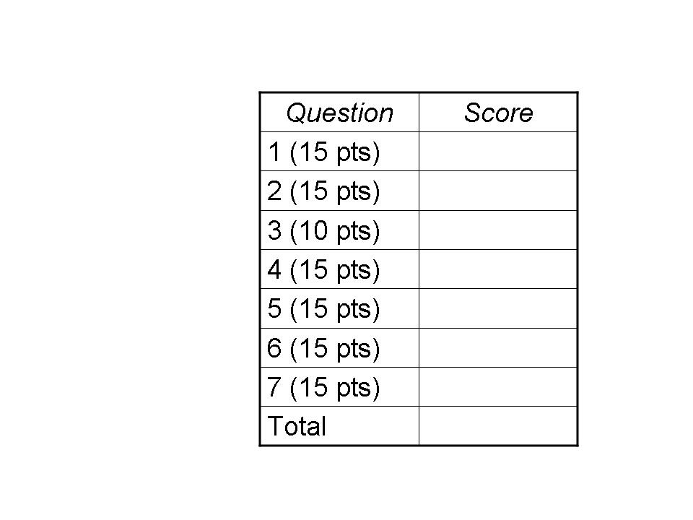

QUESTION 1: Transmission Overhead (15 POINTS)

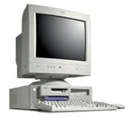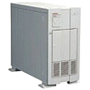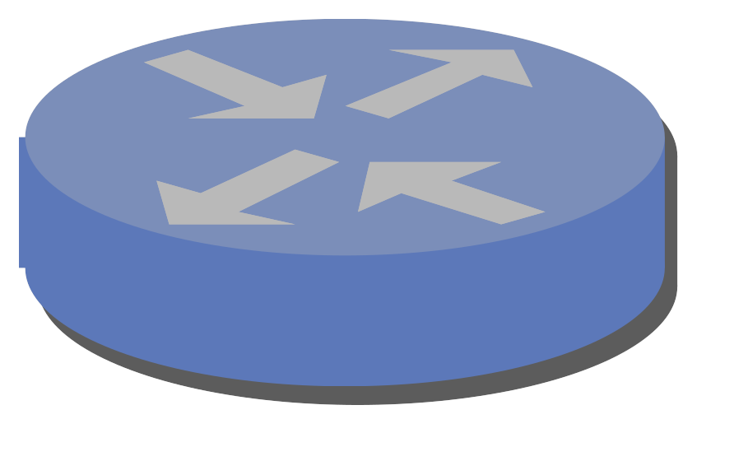
A
B
C
D

Suppose A has a TCP connection with B, where A sends data packets and B sends ACKs; similarly, suppose D has a TCP connection with C, where D sends data packets and C sends ACKs. Suppose the Maximum Segment Size (MSS) is 472 bytes, and all packets sent by A and D have this size; suppose also that B and C send an ACK in response to each data packet. Suppose that all packets have TCP and IP headers, as well as a 20-byte link-layer header/trailer. Assume the combined data and ACK packets fully utilize the middle link in both directions and no congestion control is applied.

(1a) What fraction of the bandwidth is consumed by data traffic (i.e., the TCP segments, rather than the transport, network, and link-layer information)? Feel free to express your answer as a reduced fraction (e.g., ½ or ¾) rather than a decimal number. Show your work.

Each TCP packet has three headers (at the link, network, and transport layers) and an optional segment. The link-layer header is 20 bytes, a TCP header is 20 bytes, and an IP header is 20 bytes, leading to 60 bytes of header. An ACK packet contains no payload (i.e., no segment) and, as such, is 60-bytes long. A full-sized TCP data packet includes MSS bytes (472 bytes in “part a” of the problem), in addition to the 60-byte header, resulting in 532-byte data packets. So, sending one TCP segment of 472 bytes incurs 532 bytes for the data packet and 60 bytes for the corresponding ACK packet. This leads to a ratio of 472/592, which simplifies to 59/74 – about 79.7% of the link bandwidth.

(1b) What if the MSS were increased to 1460 bytes? What is the new fraction?

As before, the equation is MSS/(MSS + 60 + 60), but now with an MSS of 1460. The resulting fraction is 1460/1580, which reduces to 73/79 – about 92.4% of the link bandwidth. Big savings!

(1c) What if the MSS were increased to 1460 bytes, and the receivers apply the delayed-ACK mechanism to send an ACK for every other data packet? What is the new fraction?

Now only half of the data packets incur the overhead of an ACK. Sending two data packets transfers 2*MSS bytes of data, leading to 2*(MSS+60) bytes in the data packets and one 60-byte ACK packet. The resulting fraction is 2*1460/(2*1460+120+60), which is 2920/3100, which reduces to 146/155 – about 94.2% of the link bandwidth.

QUESTION 2: Sockets (15 POINTS)

Consider a Web server that generates and sends HTTP response messages to clients over sockets. The header of an HTTP response message consists of a collection of lines, each ending with a carriage return and line feed. For example,

HTTP/1.1 200 OK
Server: Apache/1.2.7-dev
Date: Tue, 07 Jul 1998 18:21:41 GMT
Content-Type: text/html
…

Some early Web-server software generated the lines one at a time, and used a separate system call to write (or send) each line to the socket.

(2a) Why is this approach inefficient for the end host?

The server makes a separate system call for each line, leading to a high overhead for switching between the user-space process and the operating system. The smaller packets arriving at the client may also require the browser to perform many system calls to receive the full header, if the packets do not arrive close together in time.

(2b) Why is this approach inefficient for the network?

The resulting TCP segments are very small, in the same ballpark as the link-layer, IP, and TCP headers themselves. A large fraction of the network bandwidth is consumed by the headers. Also, the receiver must transmit ACK packets in response to receiving the data packets, leading to a large number of ACK packets.

(2c) Describe how a programmer implementing the Web server software could fix this problem.

The programmer could create a large user-space buffer (e.g., at least 1460 bytes long, if not longer) and create the response header there. Then, the programmer could make a single socket call to send the full header. The operating system will then generate large packets containing multiple lines of data and send these larger packets into the network.

QUESTION 3: IP Prefixes and Packet Forwarding (10 POINTS)

Consider the following three routers, where router R has outgoing interfaces A, B, and C:

12.0.0.0/8
12.1.0.0/16
12.2.3.0/24
R
A
B
C

(3a) How many IP addresses does the prefix 12.2.3.0/24 represent?

A 24-bit prefix means that the first 24 bits represent the network and the remaining 8 bits correspond to the specific addresses in this subnet. Hence, there are 2⁸ or 256 addresses.

(3b) List the forwarding-table entries for router R. How does R perform look-ups in this table?

12.2.3.0/24 → C
12.1.0.0/16 → B
12.0.0.0/8 → A

When a packet arrives, the router extracts the destination IP address and identifies the longest matching prefix (e.g., by scanning the above list in order, from top to bottom, until finding a match). The router then directs the packet out the interface listed in the table entry.

(3c) Which outgoing interface does R use for a packet with destination 12.2.3.1?

C – because 12.2.3.0/24 is more specific than 12.0.0.0/8

(3d) Which outgoing interface does R use for a packet with destination 12.1.2.3?

B – because 12.1.0.0/16 is more specific than 12.0.0.0/8

(3e) Which outgoing interface does R use for a packet with destination 12.2.4.5?

A – because 12.0.0.0/8 is the only matching entry in the forwarding table.

QUESTION 4: Transmission Control Protocol (15 points)

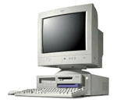

Suppose two hosts have a long-lived TCP session over a path with a 100 msec round-trip time (RTT). Then, a link fails, causing the traffic to flow over a longer path with a 500 msec RTT.

(4a) Suppose the router on the left recognizes the failure immediately and starts forwarding data packets over the new path, without losing any packets. (Assume also that the router on the right recognizes the failure immediately and starts directing ACKs over the new path, without losing any ACK packets.) Why might the TCP sender retransmit some of the data packets anyway?

TCP bases its retransmission timeout (RTO) on an estimate of the round-trip time between the sending and receiving hosts. In this example, the RTT is 100 msec before the failure. As this connection has been active for some time, the sender’s RTT estimate should pretty accurate. The RTO is typically (say) twice the RTT estimate. When the failure occurs, the increase in the actual round-trip time implies that the ACK packets will not arrive before the RTO expires. This causes the sender to presume the data packets have been lost, leading to retransmissions, despite the fact that no packets were actually lost.

(4b) Suppose instead that the routers do not switch to the new paths all that quickly, and the data packets (and ACK packets) in flight are all lost. What new congestion window size does the TCP sender use?

The TCP sender’s adjustment of the congestion window depends on how the packet losses were detected. If a triple-duplicate-ACK occurs, the congestion window would be divided in half. However, in this case, all packets in flight are lost, so no ACKs are received, forcing the sender to detect the loss via a timeout. Timeout-based loss detection leads the sender to set the congestion window to 1 (i.e., 1 MSS).

QUESTION 5: Soft State and Timer Values (15 points)

(5a) An offer message from a DHCP server includes a lease time, along with other fields like an IP address, subnet mask, DNS server address, and so on. Why is a lease time necessary?

The lease time allows the DHCP server to reclaim the IP address, even if the client never explicitly releases the address (e.g., if the client crashes or has a buggy DHCP implementation).

(5b) A DNS response message from a DNS server includes a time-to-live field. Why is this necessary?

The time-to-live field determines how long the client can safely cache the response. Otherwise, a client might cache a name-to-address (or address-to-name) mapping indefinitely. Yet, the mapping may need to change over time. For example, a Web site may move from one hosting provider to another, forcing a change of IP address. Even if a site does not change providers, DNS may be used to control how Web clients are directed to different replicas (e.g., for load balancing), so the ability to adjust the mapping over time is important, requiring a mechanism for flushing the DNS cache. Using a TTL places the responsibility for flushing the cache at the client, rather than requiring the server to remember (and contact) all past clients to notify them when the mapping information has changed.

(5c) The IP packet header includes a time-to-live field that is decremented by each router along the path. Why is the time-to-live field necessary?

A packet may get stuck in a forwarding loop (e.g., due to a router configuration mistake). By decrementing the TTL field at each hop, and discarding the packet when the TTL reaches 0, the network prevents the packet from cycling in a loop indefinitely. Otherwise, the packet would consume excessive resources, or even escape the loop eventually and reach the destination much later (running the risk that the packet is mistakenly viewed as part of a more recent transmission with the same IP addresses and TCP/UDP port numbers).

(5d) A Network Address Translator (NAT) has a binding timer associated with each map entry. Why is this necessary?

Eventually, the NAT box needs to reclaim memory and port numbers to use for new data transfers. Also, a stale map entry could be viewed as a security risk, as an attacker could send packets to the hosts behind the NAT box using a source address and port number of a past transfer.

(5e) Why does a TCP sender use a very large retransmission timeout (e.g., several seconds) to detect and retransmit a lost SYN packet?

The TCP sender does not have any initial estimate of the round-trip time (RTT). Starting with a conservative retransmission timeout (RTO) prevents the excessive retransmissions that would result from using an RTO that is smaller than the actual RTT.

QUESTION 6: Layering (15 points)

(6a) Why do DNS queries and responses use UDP instead of TCP? Why do live audio and video traffic typically use UDP?

DNS query and response messages are short enough to fit in a single packet, making the connection set-up and tear-down overhead of TCP overkill.

For live audio and video, retransmitting a lost packet is not useful if the retransmitted packet will arrive after the playback time. In addition, retransmissions and congestion control may cause the receiver not to receive the data fast enough to continue with real-time playback. (Also, the UDP header is smaller than the TCP header, and as such consumes less bandwidth. This is important for audio traffic, where the packet payload is typically small.)

(6b) List three key differences between MAC and IP addresses.

MAC addresses are flat, whereas IP addresses are hierarchical.
MAC addresses are 48-bits long, whereas IPv4 addresses are 32-bits long.
MAC addresses are globally unique, whereas IP addresses are not necessarily.
MAC addresses are burned into the device, whereas IP addresses may be assigned dynamically.
MAC addresses are used at the link layer within a single network, whereas IP addresses are used at the network layer between networks.

(6c) List three key reasons for a host to have both a domain name and an IP address.

Names are easier for humans, whereas numerical addresses are easier for computers.
The IP address can change (e.g., due to switching service providers) while keeping the name of the site the same.
A name may map to multiple addresses (e.g., replicas of a service, perhaps at multiple locations).

(6d) Why has Network Address Translation been so widely deployed, despite the intent that it was meant to provide temporary relief from IP address space exhaustion until IPv6 could be designed and deployed?

NAT is plug-and-play, whereas IPv6 requires upgrades to the hosts and routers to implement the new network-layer protocol. Also, NAT offers additional advantages, such as hiding multiple machines behind a single IP address allocated by a service provider.

(6e) Why does the Ethernet frame include a type field that indicates the network-layer protocol?

The network-layer information is necessary to demultiplex to the appropriate network protocol (e.g., IP, IPX, or Appletalk) at the receiving node. This is necessary to know the format of the network-layer header that follows in the payload of the Ethernet frame.

QUESTION 7: Randomization (15 points)

(7a) When starting a new TCP connection, why do the sender and receiver each pick a random initial sequence number (ISN)? Why not start every TCP transfer with a sequence number of 0?

The port numbers in TCP connections come from a finite range and, as such, are reused over time. As such, it is possible that two communicating hosts are using a pair of port numbers that were used in the past. It is conceivable that a packet from the earlier connection is still in flight and might reach the receiver. To reduce the likelihood that the old packet is viewed as part of the ongoing transfer, the starting sequence number changes over time.

(7b) Why does Random Early Detection (RED) selectively mark or drop some packets, even before the queue is full? Why is this done randomly, rather than deterministically? What are the implications if the mark/drop probability is set too high? Too low?

RED marks/drops packets to signal the affected TCP senders to drop their sending rates, hopefully before it is too late. Dropping early (and selectively) avoids generating a burst of losses across a large number of TCP connections, which might lead to a synchronized response where too many connections decrease their sending rates.

Random marking/dropping at the packet level is fair because it marks/drops packets in proportion to the rate of the each flow. Also, random choices help prevent synchronization, and don’t require much state to implement.

Dropping too aggressively would lead to under utilization of the network, and wasted bandwidth for the packets that were dropped en route to their destinations. Dropping too little can drive the system into drop-tail queuing, with the associated problems of synchronized losses.

(7c) Why do Ethernet adaptors select a random back-off time before trying to transmit a frame following a collision? Why do they pick the random back-off time from a larger range after each collision?

Random back-off times reduce the likelihood of a future collision, without requiring any explicit coordination between the senders to schedule their transmission times. When more collisions occur, this means that the link is likely quite heavily loaded (i.e., many adaptors are trying to transmit). Picking from a larger range helps avoid future collisions, and essentially expands the back-off times to allow each of the adaptors to have a turn, without explicit coordination to learn exactly how many adaptors have data awaiting transmission. Pretty nifty!

