NAME:

Login name:

Computer Science 461
Midterm Exam
March 30, 2009
1:30-2:50pm

This test has six (6) questions. Put your name on every page, and write out and sign the Honor Code pledge before turning in the test.

Please look through all of the questions at the beginning to help in pacing yourself for the exam. The exam has 100 points and lasts for 80 minutes, so the number of minutes spent per question should be less than its point value. You should spend no more than 10-12 minutes per question. Show your work for all problems. Partial credit will often be given.

"I pledge my honor that I have not violated the Honor Code during this examination.''

Question | Score
1 | / 15
2 | / 16
3 | / 17
4 | / 14
5 | / 16
6 | / 22
Total | / 100

QUESTION 1: Transporting a file (15 POINTS)

Suppose your boss calls you up while visiting a client and says he left a 250,000 byte file on a server at the office, and he needs you to send it to him. The connection between the office and his current site is 2 million bits/second.

1A. [2 points] Assuming that all bandwidth is consumed by your data (e.g., there aren’t any packet headers, there’s no other traffic on the link, etc.) and that you can immediately start sending data at the maximum rate, how long will it take to transmit the file? (Easy)

1B. [5 points] Now assume that you are sending the file via TCP, with a maximum segment size of 1000 bytes. You have to follow TCP’s transport algorithm, so you start transmitting the file at a low rate. How many network round trip times (RTTs) will it take to transmit the entire file? Again assume that all bandwidth is consumed by your data.

1C. [4 points] Let’s now consider how TCP reacts when it encounters packet loss (the “basic” variant we learned in class). Your boss now wants you to transmit a much larger file (say, 1 GB). This time around, after TCP reaches an instantaneously transmission rate of 32,000 bytes per second, you notice that a single packet is lost. Assuming that you don’t currently have any other packets in transmission, what is the instantaneous rate TCP will send at after noticing that loss? How long (in terms of RTTs) will it take to reach 32,000 bytes per second again?

1D. [4 points] In the previous example of 1c, would anything be different if all packets were lost after you reached 32,000 bytes per second, instead of just a single packet? If so, what is the next instantaneous rate TCP will send at in this example, and how long (in terms of RTTs) would it now take to reach 32,000 bytes per second again?

QUESTION 2: Sockets (16 POINTS)

2A. [10 points] In the first assignment, you used the socket API to write a simple client/server. For this question, there is a single client communicating with a single server using TCP. The client sends a very small amount of data using the send() function, and the server receives the data with a recv() call. Each of the following scenarios shows a diﬀerent order in which the socket calls are called on both the client and the server.

Assume all system calls are blocking, and there may be some latency between the client and server. We write the system call when it is initiated by the client and/or server; it returns sometime between then and when the next local system call is executed.

For each scenario, answer the following: Can the server ever get the data sent by the client? (Yes or No). If not, explain why not.

i)
Client | Server
socket()  connect()  send()  close() | socket()  bind()  listen()  accept()  recv()  close()

ii)
Client | Server
socket()  connect()  send()  close() | socket()  bind()  listen()  accept()  recv()  close()

iii)
Client | Server
socket()  connect()  send()  close() | socket()  bind()  listen()  accept()  recv()  close()

iv)
Client | Server
socket()  connect()  send()  close() | socket()  bind()  listen()  accept()  recv()  close()

v)
Client | Server
socket()  connect()  send()  close() | socket()  bind()  listen()  accept()  recv()  close()

2B. [3 points] Suppose application A is using a stream (TCP) socket to transfer data to application B on a remote host. Suppose application A writes (sends()) data into the socket buffer ten times.

i) Can the underlying network stack transmit more than ten data packets? If so, why?

ii) Can the underlying network stack transmit fewer than ten data packets? If so, why?

2C. [3 points] Suppose application A is using a datagram (UDP) socket to transfer data to application B on a remote host. Suppose application A calls sendto() ten times.

i) Can the underlying network stack transmit more than ten data packets? If so, why?

ii) Can the underlying network stack transmit fewer than ten data packets? If so, why?

QUESTION 3: Your Web Browser in action (17 POINTS)

In the topology shown below, machine A is a desktop client, D is a local DHCP server, R is A's gateway router, S is a Web server, and C is a Web cache. N_{L} is C's local nameserver, while N_{A} is the nameserver authoritative for S. Client A is conﬁgured to use Web cache C for all requests (assume that the Web cache resolves the name for any Web server and that the client is conﬁgured with the IP address of the cache). All wires/links are Ethernet segments.

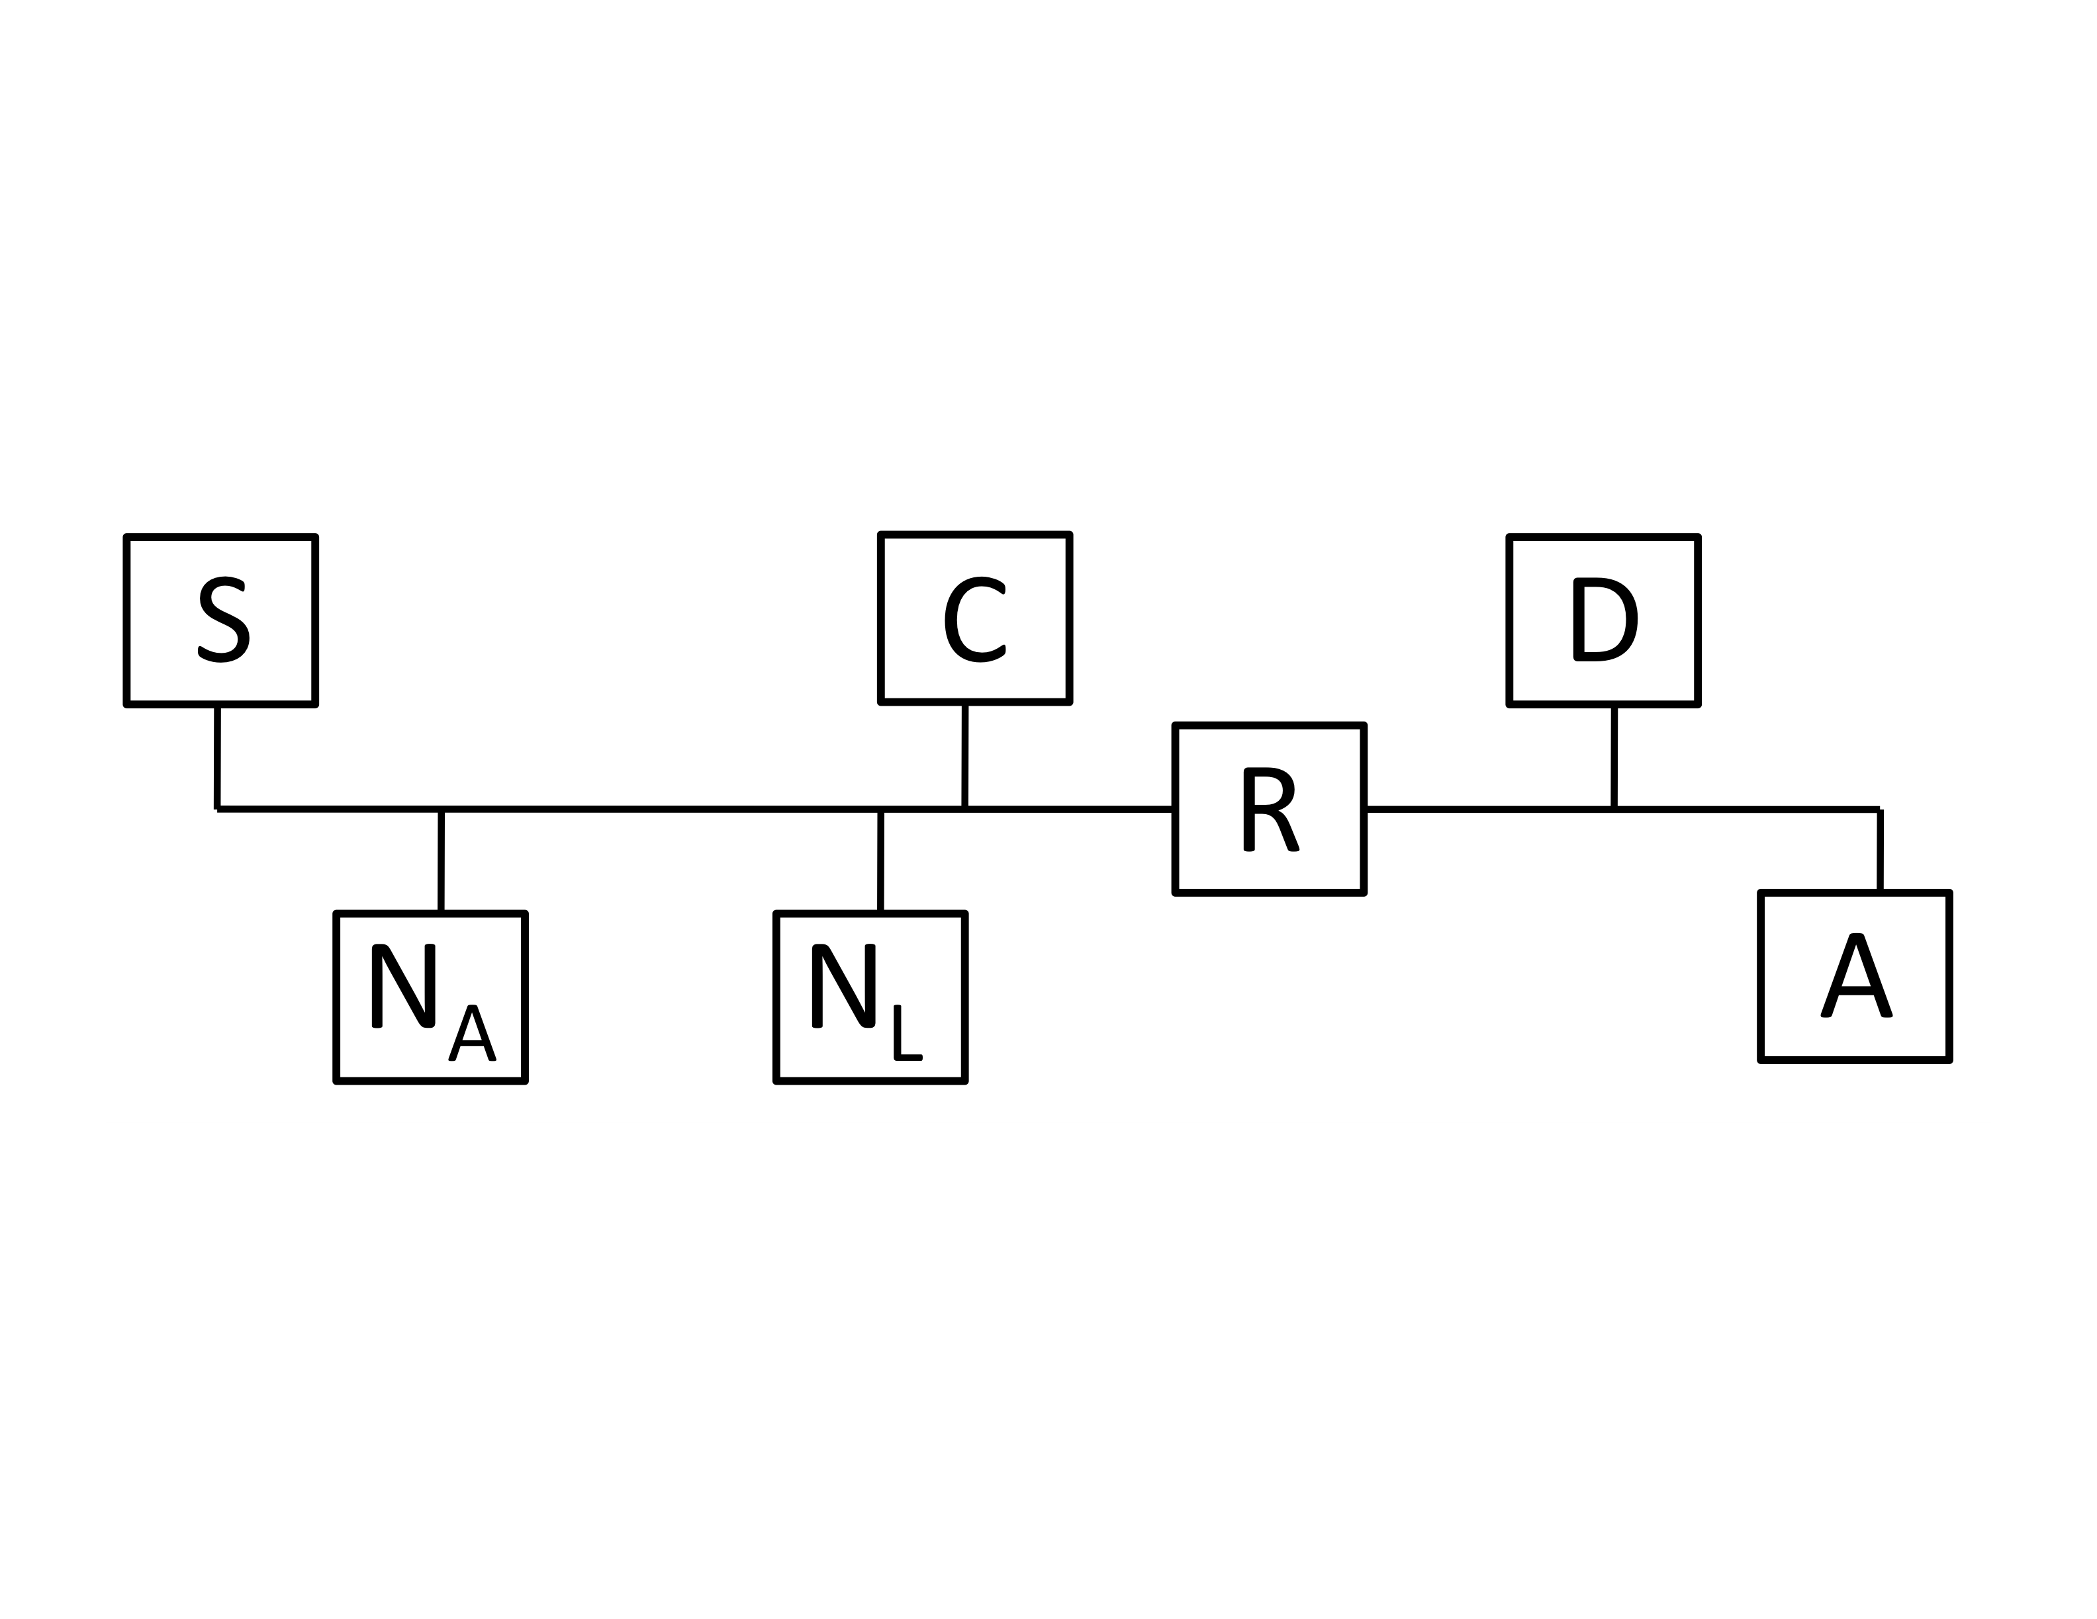
Assume the following:
- All the machines were just booted and their associated caches (ARP, DNS, Web, persistent connections) are all empty
- http://S/index.html ﬁts in a single packet
- Persistent HTTP connections are used among A, C, and S (i.e. you should assume that once any connection between these hosts is established it is never closed)
- Web caches respond to TCP requests that look like packet two in table 1 below (e.g., GET http://foo/bar/). They reply with the normal web cache contents.

3A. [12 points] The user on machine A, requests the web page http://S/index.html. The table below shows a number of messages sent/received in servicing this request (this is not necessarily a complete list of all packets). In addition, there are a few bogus packets that are never sent/received. The packets are not listed in temporal order.

ID | SRC | DST | SRC Port | DST Port | Protocol | Contents
1 | C | DNS root |  | DNS | UDP | Query for S
2 | A | C |  | Web cache | TCP | GET http://S/index.html
3 | N_{L} | DNS root |  | DNS | UDP | Query for S
4 | C | S |  | HTTP | TCP | SYN
5 | C | S |  | HTTP | TCP | GET index.html
6 | S | A | HTTP |  | TCP | index.html
7 | A | Broadcast |  |  | ARP | Who is R
8 | C | A | Web cache |  | TCP | index.html
9 | N_{L} | C | DNS |  | UDP | Address for S
10 | S | C | HTTP |  | TCP | index.html
11 | A | Broadcast |  | DHCP | UDP | DHCP Request from A
12 | N_{L} | N_{A} |  | DNS | UDP | Query for S

List the proper order of packets (in terms of their IDs) that are sent on the network:

3B. [5 points] Assume that the client A has no local Web or DNS cache and that cache C has no DNS cache. However, all other cacheable things are cached. On a subsequent request for http://S/ index.html, which of your items from your list in 3A would be eliminated? (Use the ID column to name the messages.)

QUESTION 4: A routed and bridged network (14 POINTS)

Above is a picture of a network with 2 bridges and 1 router. Each interface is labeled with both an IP address and a MAC address. Imagine that host H1 is sending a packet to host H2. Please answer the following questions about this ﬁgure:

4A. How many (datalink) networks are shown above?

4B. Just before the packet reaches bridge B1, what is its layer 2 destination?

4C. Just before the packet reaches bridge B2, what is its layer 2 source?

4D. Just after the packet leaves router R2, what is its layer 3 source?

4E. When H1 sends out an ARP query, what is the reply to that query?

4F. Does the entry B2a.mac appear in B1’s forwarding table?

4G. Will SRC's Ethernet device receive packets with destination R2a.mac? Why / why not?
QUESTION 5: Multiple choice (16 points)

5A. Which best describes the Ethernet protocol? (Circle ONE)
A. Talk only if you hear no one else talking, but stop as soon as you hear anybody else.
B. Pass a ticket around and only talk if you are holding the ticket.
C. Raise your hand and wait till a moderator gives you permission to talk.
D. Every person is scheduled a time to talk.

5B. Which of the following is/are true about Ethernet: (Circle ALL that are correct)
A. CRC error detection, as used in Ethernet, cannot always detect if there is a frame error.
B. In the Ethernet CSMA/CD protocol, suppose that an adapter constructs a frame to send and then senses that the channel is busy. The adapter then enters exponential back-oﬀ.
C. Entries in an Ethernet bridge table must be conﬁgured by a network administrator.
D. An Ethernet adapter always passes all non-corrupt frames that it receives up to the network layer.

5C. Which of the following is/are true about Address Resolution Protocol (ARP) and learning bridges? (Circle ALL that are correct)
A. A learning bridge maintains state that maps IP addresses to hardware (MAC) addresses.
B. A learning bridge maintains state that maps MAC addresses to IP addresses.
C. A host’s ARP table maintains state that maps IP addresses to hardware (MAC) addresses.
D. A host’s ARP table maintains state that maps hardware addresses to IP addresses.

5D. Which of the following is/are true about a communications channel that uses time- division multiplexing? (Circle ALL that are correct)
A. There may be times when the channel is idle, even if a sender has data to send on the channel.
B. The channel requires the sender’s and receiver’s clocks to be closely synchronized.
C. Data in the channel could experience variable delays due to queuing.
D. In times of high utilization, a sender could be completely denied access to the channel.

5E. Which of the following is/are true about increase/decrease policies for fairness and
efﬁciency in congestion control? (Circle ALL that are correct)
A. Additive increase reduces fairness.
B. Additive increase improves efﬁciency.
C. Multiplicative increase improves fairness.
D. Multiplicative decrease improves fairness.

5F. Which of the following is/are true about DNS? (Circle ALL that are correct)
A. A query for an A record may return multiple IP addresses in the response.
B. A query for an NS record may return multiple IP addresses in the response.
C. A short TTL on an NS record reply runs the risk of increasing trafﬁc at the root or GTLD nameservers.
D. A short TTL on an A record reply runs the risk of increasing trafﬁc at the root or GTLD nameservers.

5G. Which of the following is/are true about web caches? (Circle ALL that are correct)
A. A web cache, or proxy server, is a network entity that satisﬁes HTTP requests from clients.
B. A web cache is both a client and a server at the same time.
C. HTTP does not explicitly support caching or cache consistency.
D. All HTTP objects are cacheable.

5H. Which of the following is/are true about persistent HTTP connections? (Circle ALL that are correct.)
A. Persistent HTTP allows a server to track the client’s requests through a persistent session.
B. Only one TCP connection must be opened for downloading a "page", if that page does not include any embedded objects served by other servers.
C. Persistent HTTP shows the greatest performance advantage over nonpersistent HTTP when downloading a page with large objects.
D. When the server has ﬁnished sending data for all objects referenced by the initially requested page, the server closes the connection.

QUESTION 6: Short Answer (22 points)

6A. [2 points] Explain the principle of soft state. Provide two examples of a network protocol or
technology that abides by soft state.

6B. [2 points] List two protocols that use exponential backoff, and describe what/where problems would occur if each protocol did not backoff.

6C. [3 points] List three possible explanations for why host A would need to retransmit the SYN packet as part of establishing the TCP connection with B.

6D. [1 point] Give one reason that DNS lookups are run over UDP rather than TCP

6E. [2 points] Give two reasons that sites use Network Address Translators (NATs):

6F. [3 points] When a packet is going from a local-area network onto the wider Internet, what header fields might a Network Address Translator (NAT) change that is deployed on path?

6G. [3 points] How does explicit congestion notification (ECN) differ from traditional ways of detecting congestion on Internet paths? Describe one benefit for using ECN and one reason it might not widely be used today.

6H. [4 points] The OSI model is traditionally seen as a 7-layer stack consisting of the following. For several of the layers, give one or two examples of protocols that are associated with each layer:

Application | 2 examples:
Presentation
Session
Transport | 2 examples:
Network | 1 example:
Data link | 2 examples:
Physical | 1 examples:

6I. [1 point] What's the first name of your favorite TA? Why?

6J. [1 point] Describe one thing you would like to see changed in the class. (Only wrong answer is "nothing".)

