NAME:

Login name:

Computer Science 461
Midterm Exam
March 12, 2008
1:30-2:50pm

This test has seven (7) questions. Put your name on every page, and write out and sign the Honor Code pledge before turning in the test.

Please look through all of the questions at the beginning to help in pacing yourself for the exam. The exam has 100 points and lasts for 80 minutes, so the number of minutes spent per question should be less than its point value. You should spend no more than 10-12 minutes per question.

``I pledge my honor that I have not violated the Honor Code during this examination.''

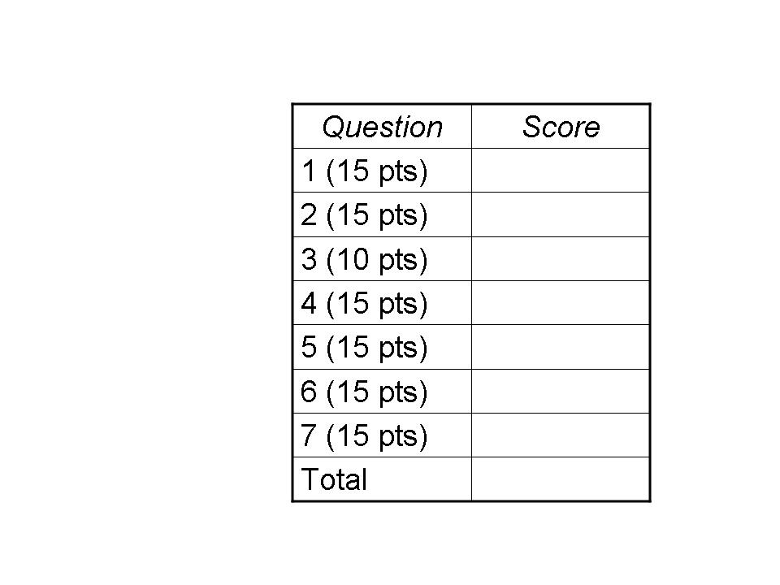
QUESTION 1: Big MAC (15 points)

This question explores whether the Internet could be designed using only names (like www.frieswiththat.com) and MAC addresses, without a need for IP addresses. Suppose each network adapter, for any link technology, has a unique MAC addresses from a single address space (such as 48-bit MAC addresses used for Ethernet devices), and these addresses were used Internet-wide for communication between end hosts. Suppose that the Domain Name System (DNS) is changed to return MAC addresses rather than IP addresses, in response to queries.

(1a) In today’s Internet, why is it difficult to support continuous communication with a host while it moves? Why would an Internet based on MAC addresses have the potential to make mobile hosts easier to support?

(1b) Today’s local area networks have several “boot-strapping” techniques, such as DHCP, ARP, and MAC learning. In a world without IP addresses, which of these techniques would still be necessary? Explain your answer.

(1c) How would moving to an Internet based on MAC addresses affect the size of the forwarding tables in the network nodes (i.e., routers or switches)?

(1d) How would the new design, based on MAC address, affect users’ privacy?

QUESTION 2: Stuck in the Middle (15 POINTS)

The end-to-end principle argues for placing functionality at the end-points of communication, unless performance dictates otherwise. In this question, we explore the efficiency trade-offs in providing reliable data delivery over unreliable components. Suppose host A transmits data to host B over a two-hop path. The first hop is a lossy wireless link that randomly drops 10% of packets. The second hop is a relatively reliable wired link that randomly drops 1% of packets. If the answers to the questions below require extensive arithmetic, feel free to simply specify the required computation rather than computing the final answer. Show your work.

(2a) What is the likelihood that a packet successfully traverses both links?

(2b) If a packet is lost on either link, the sender must retransmit the packet over the entire path. What is the likelihood that the packet must be transmitted more than five times (i.e., retransmitted more than four times)?

(2c) Suppose the node in the middle of the path can send acknowledgments (if the packet successfully arrived from A) and retransmit packets (if no acknowledgment is received from B). Assume acknowledgments are always successfully delivered. What is the likelihood that the middle node must transmit a packet more than five times on the second link, leading to node B?

(2d) The involvement of the middle node also (slightly) reduces the number of times A must send the packet over the first (more lossy) link. How much does the middle node’s help reduce the likelihood that the packet must be sent over the first hop more than five times?

QUESTION 3: Going With the Flow (10 points)

(3a) A home user upgrades from a dial-up connection to high-speed broadband, but does not see much improvement in Internet performance for visiting a Web site. Give one reason why this might happen, even if the network and the Web server have ample capacity.

(3b) When a path through the Internet becomes overloaded, the total “goodput” seen by all end users can actually decrease. Explain why.

(3c) Why are many packet losses in wireless networks detected by a timeout rather than a triple-duplicate acknowledgment? What are the performance implications?

(3d) A router maintains a queue of packets awaiting transmission on a link. Selecting the right buffer size is a challenging problem. Give one reason why a large buffer would be desirable. Give two reasons why a larger buffer might be undesirable.

QUESTION 4: Caught in the Web (15 POINTS)

(4a) In the three-way handshake to open a TCP connection, host A sends a SYN, host B sends a SYN-ACK, and host A sends an ACK. When can the TCP implementation at host A start sending data packets? When can the TCP implementation at host B start sending data packets? Explain why they cannot start sending any sooner.

(4b) HTTP/1.1 supports persistent connections, where multiple request-response exchanges use the same TCP connection. With pipelining, the client might send multiple requests before receiving any responses. How does the server know where one request ends and the next begins?

(4c) Following up on question 4b, the underlying TCP implementation does not ensure that each read() or recv() call returns a single complete HTTP request. Give two reasons (or examples) why the TCP implementation in the operating system cannot do this.

(4d) Give two reasons why persistent connections and pipelining were added to HTTP/1.1. Why, then, do Web browsers typically disable pipelining by default?

(4e) What happens, at the socket level, when the user clicks “reload” on a Web browser when the data transfer is proceeding slowly? Why does this often lead to a faster download?

QUESTION 5: Losing Control (15 points)

The File Transfer Protocol (FTP) is an application-layer protocol used to transfer data from one computer to another. FTP runs over TCP. The server, by default, listens on port 21 for incoming connections. The FTP client uses this connection as a “control” connection for sending commands (e.g., to list files, request file transfers, and change directories). The actual file transfer uses a separate TCP connection. Hence, unlike HTTP which has a single connection for both control and data, FTP has “out of band” control over a separate connection.

The client and the server need to agree on the port numbers to use for the separate data-transfer connection. In one solution, called “active mode,” the client opens a socket with a dynamic port and sends the IP address and port number to the server (using the existing control connection) so the server knows what client address and port number to use for the data-transfer connection. (For example, the client on IP address 192.168.0.1 that chose port 49152 for the data connection might send a command like “PORT 192.168.0.1 49152” over the control connection.)

(5a) Active mode can cause problems when the client host resides behind a NAT box. Why?

(5b) Suppose a NAT box wanted to correctly handle clients running “active mode” FTP. What actions would the NAT box need to perform on FTP control messages from the client?

(5c) Why might these operations change the size of underlying IP packets associated with the control connection? How could the NAT handle the change in packet sizes?

(5d) What challenges are introduced if other applications (besides FTP control) use port 21? What challenges are introduced if the FTP client and FTP server encrypt their communications?

(5e) FTP has an alternate way to establish the data-transfer connection, called “passive mode,” where the server selects a port number and instructs the client (using the existing control connection) to establish the data-transfer connection. Why is passive mode easier than active mode in the presence of client-side NAT boxes?

QUESTION 6: A Rose by Any Other Name (15 points)

This question explores the challenges of the Domain Name System.

(6a) Before the 9/11 attacks, the top-level domain (TLD) server for South Africa was located in New York City. Explain why the physical destruction on 9/11 disrupted Internet communication within South Africa (e.g., for a Web user in South Africa accessing a Web site in South Africa)?

(6b) Following up on question 5a, explain why the effects in South Africa took place gradually, disrupting progressively more communication within the country in the hours (and even days) after connectivity to NYC was lost.

(6c) How do the local DNS servers know the identity of the root servers? Why are most of the host-to-address queries seen by the root DNS servers for bogus or malformed names (like graceland.elvis or numeric top-level domains)?

(6d) Who determines the value of the time-to-live field that determines how long DNS servers cache a name-to-address mapping? What are the pros and cons of using a small value?

(6e) A local DNS server typically discards cached name-to-address mappings when the time-to-live expires. Alternatively, the local DNS server could optimistically issue a new query for the cached domain name. Given one advantage and one disadvantage of that approach.

QUESTION 7: For Good Measure (15 points)

(7a) Traceroute capitalizes on the “Time To Live” field in the IP packet header to measure the forwarding path from one host to another. Give two reasons why a hop in traceroute might show a “*” (i.e., no IP address for the router at that hop in the path).

(7b) Traceroute may report a path that does not exist. For example, traceroute could return a path A-B-C (where A, B, and C are IP addresses) when there is no link between routers B and C. Give one example where that could happen. (Draw a picture if useful.)

(7c) The delay between a TCP sender transmitting a SYN packet and receiving the SYN-ACK packet provides an estimate of the round-trip time between a client and a server. Give one reason why, on average, the SYN/SYN-ACK delay is larger than a typical round-trip delay between a client and server. Assume all DNS and ARP look-ups have already completed.

(7d) Determining the geographic location of an Internet host, based on its IP address, is challenging. Propose two techniques that could be used to infer the rough location.

(7e) Suppose a host’s local DNS server records the round-trip time for a successful query to an authoritative DNS server. This could be used as an estimate of the expected round-trip time for the host to communicate with machines at the remote site. Give one reason why this is a good heuristic for estimating the round-trip time between two hosts, and one reason why it is not.

