NAME:

Login name:

Computer Science 461
Midterm Exam
March 12, 2008
1:30-2:50pm

This test has seven (7) questions. Put your name on every page, and write out and sign the Honor Code pledge before turning in the test.

Please look through all of the questions at the beginning to help in pacing yourself for the exam. The exam has 100 points and lasts for 80 minutes, so the number of minutes spent per question should be less than its point value. You should spend no more than 10-12 minutes per question.

``I pledge my honor that I have not violated the Honor Code during this examination.''

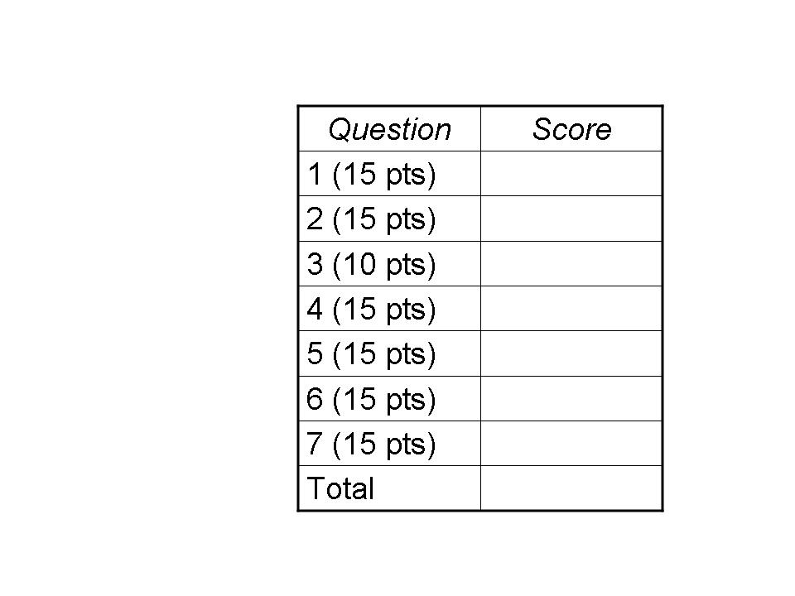
QUESTION 1: Big MAC (15 points)

This question explores whether the Internet could be designed using only names (like www.frieswiththat.com) and MAC addresses, without a need for IP addresses. Suppose each network adapter, for any link technology, has a unique MAC addresses from a single address space (such as 48-bit MAC addresses used for Ethernet devices), and these addresses were used Internet-wide for communication between end hosts. Suppose that the Domain Name System (DNS) is changed to return MAC addresses rather than IP addresses, in response to queries.

(1a) In today’s Internet, why is it difficult to support continuous communication with a host while it moves? Why would an Internet based on MAC addresses have the potential to make mobile hosts easier to support?

Mobility is difficult to support in today’s Internet because a host’s IP address changes as it moves, since IP addresses are allocated to institutions in a hierarchical fashion. Dynamic changes in the host’s IP address make it difficult to sustain a connection (e.g., TCP or UDP socket) with another host. An Internet based on MAC addresses would allow the host’s identifier to stay the same as it moves.

(1b) Today’s local area networks have several “boot-strapping” techniques, such as DHCP, ARP, and MAC learning. In a world without IP addresses, which of these techniques would still be necessary? Explain your answer.

DHCP would no longer be needed to assign an IP address or network mask to the host, though a similar mechanism may still be needed to configure the address of the local DNS server and the gateway router. ARP would no longer be necessary, as there would be no need to map an IP address to a MAC address. MAC learning would still be necessary to enable switches to learn how to forward frames to a host based on its MAC address.

(1c) How would moving to an Internet based on MAC addresses affect the size of the forwarding tables in the network nodes (i.e., routers or switches)?

Forwarding tables could grow quite large because MAC addresses are not hierarchical. Today, routers store ~200K IP prefixes that represent a much larger number of hosts. Within a local area network, switch forwarding tables could likely stay the same size, as hosts could direct external traffic (destined to the rest of the Internet) to the gateway router.

(1d) How would the new design, based on MAC address, affect users’ privacy?

Hosts throughout the Internet would know the MAC address of the machine sending the traffic (e.g., to a Web site), leading to less privacy compared to IP addresses. Yet, the remote machine would not necessarily know where the host is located, which may improve privacy.

QUESTION 2: Stuck in the Middle (15 POINTS)

The end-to-end principle argues for placing functionality at the end-points of communication, unless performance dictates otherwise. In this question, we explore the efficiency trade-offs in providing reliable data delivery over unreliable components. Suppose host A transmits data to host B over a two-hop path. The first hop is a lossy wireless link that randomly drops 10% of packets. The second hop is a relatively reliable wired link that randomly drops 1% of packets. If the answers to the questions below require extensive arithmetic, feel free to simply specify the required computation rather than computing the final answer. Show your work.

(2a) What is the likelihood that a packet successfully traverses both links?

The probability of success on the first hop is 90%. Given success on the first hop, the likelihood of success on the second hop is 99%. The likelihood of traversing both is .9 * .99, or .891, or 89.1%.

(2b) If a packet is lost on either link, the sender must retransmit the packet over the entire path. What is the likelihood that the packet must be transmitted more than five times (i.e., retransmitted more than four times)?

Drawing on the result from question 2a, the likelihood the packet is lost somewhere on the path is 1-.891, or 0.109, or 10.9%. The likelihood the packet is transmitted more than five times (i.e., sent once and retransmitted more than four times) is the same as the probability it is lost at least 5 times. This is (.109)⁵ or 1.53862395 × 10⁻⁵, or 0.00153862395%.

(2c) Suppose the node in the middle of the path can send acknowledgments (if the packet successfully arrived from A) and retransmit packets (if no acknowledgment is received from B). Assume acknowledgments are always successfully delivered. What is the likelihood that the middle node must transmit a packet more than five times on the second link, leading to node B?

The middle node only retransmits a packet that is lost on the second link, with 1% probability. The likelihood that the packet is transmitted more than five times, or retransmitted five or more times, is (0.01)⁵ or 10⁻¹⁰.

(2d) The involvement of the middle node also (slightly) reduces the number of times A must send the packet over the first (more lossy) link. How much does the middle node’s help reduce the likelihood that the packet must be sent over the first hop more than five times?

The first node only retransmits a packet that was lost on the first link, with 10% probability (instead of 10.9% probability in question 2a). As such, the absolute difference is (.109)⁵-(.1)⁵. The ratio between the two is (.109)⁵/(.1)⁵, or (.109/.1)⁵, or (1.09)⁵, or 1.5386.

QUESTION 3: Going With the Flow (10 points)

(3a) A home user upgrades from a dial-up connection to high-speed broadband, but does not see much improvement in Internet performance for visiting a Web site. Give one reason why this might happen, even if the network and the Web server have ample capacity.

The size of the receiver window (RWIN) may limit the throughput. In particular, the throughput is limited by the RWIN/RTT, where RTT is the round-trip time between the host and the Web server. The home user can improve performance by changing the maximum TCP receiver window (e.g., from 16 KB to 64 KB).

Also, most Web transfers are short (e.g., fewer than 10 packets long). For these transfers, the download time is typically dominated by the round-trip time, as the TCP connection doesn’t get out of slow start and does not fill the receiver window.

(3b) When a path through the Internet becomes overloaded, the total “goodput” seen by all end users can actually decrease. Explain why.

When the network is congested, many packets travel part way through the network, only to be lost and ultimately retransmitted by the sender. The wasted bandwidth may cause other packets to encounter congestion, and experience packet loss and subsequent retransmission, leading to an overall drop in the rate of successful packet delivery.

(3c) Why are many packet losses in wireless networks detected by a timeout rather than a triple-duplicate acknowledgment? What are the performance implications?

Wireless networks tend to experience bursty packet losses due to interference (e.g., signal blocked by a building). This decreases the likelihood that, in the same TCP sending window, some packets are lost while others are successfully delivered. The successful deliveries are necessary to trigger the receiver to send duplicate acknowledgments. As such, bursty loss tends to require the sender to rely on the retransmission timeout to detect the loss. (In addition, many wireless networks have relatively low capacity, leading the sender to have a relatively small congestion window. This also decreases the likelihood that enough packets are successfully delivered to enable detection of an earlier packet loss by duplicate acknowledgments. Similarly, wireless users may do smaller transfers, due to limited bandwidth or small screen sizes of PDAs, and small transfers offer less opportunity for multiple packets in flight during the same RTT.)

(3d) A router maintains a queue of packets awaiting transmission on a link. Selecting the right buffer size is a challenging problem. Give one reason why a large buffer would be desirable. Give two reasons why a larger buffer might be undesirable.

A larger buffer can temporarily accommodate a burst of packets without dropping any of them, avoiding unnecessary retransmissions. However, a larger buffer would (i) increase the round-trip time leading to higher and more unpredictable delays, (ii) increase the time for the TCP senders to learn about impending congestion, and (iii) make the router more expensive (due to more memory chips and higher power requirements).

QUESTION 4: Caught in the Web (15 POINTS)

(4a) In the three-way handshake to open a TCP connection, host A sends a SYN, host B sends a SYN-ACK, and host A sends an ACK. When can the TCP implementation at host A start sending data packets? When can the TCP implementation at host B start sending data packets? Explain why they cannot start sending any sooner.

Host A can start sending upon receiving the SYN-ACK, since that signals to host A that B is willing to accept traffic and knows A’s initial sequence number. Host B can start sending traffic upon receiving the ACK, since that signals to host B that A is willing to accept traffic and knows B’s initial sequence number.

(4b) HTTP/1.1 supports persistent connections, where multiple request-response exchanges use the same TCP connection. With pipelining, the client might send multiple requests before receiving any responses. How does the server know where one request ends and the next begins?

The server identifies request boundaries by parsing the HTTP requests, e.g., based on the CRLF and/or the Content-Length.

(4c) Following up on question 4b, the underlying TCP implementation does not ensure that each read() or recv() call returns a single complete HTTP request. Give two reasons (or examples) why the TCP implementation in the operating system cannot do this.

The TCP implementation provides a stream-of-bytes abstraction, without any knowledge of the syntax of the application-layer message(s). Also, the application-layer message may be larger than the operating system’s receiver buffer and/or the buffer provided by the application, making it impossible for the operating system to provide the entire request in response to a single read() or recv() call. Also, it is possible that the full request (even if it could fit in the buffer) has not arrived yet, causing the read/recv call to return only the data that has arrived thus far.

(4d) Give two reasons why persistent connections and pipelining were added to HTTP/1.1. Why, then, do Web browsers typically disable pipelining by default?

These features were added to HTTP to (i) avoid the extra TCP traffic needed to open and close many TCP connections, (ii) avoid repeating slow start and the whole process of relearning the congestion state of the path through the network, (iii) to ensure fairness across different Web clients receiving traffic over the same path, and (iv) to reduce the number of round-trip delays experienced by the user in downloading a Web page.

Web browsers often disable pipelining because (i) parallel connections may allow the client to experience higher throughput (possibly at the expense of other users) and (ii) parallel connections enable the simultaneous download and display of multiple embedded images.

(4e) What happens, at the socket level, when the user clicks “reload” on a Web browser when the data transfer is proceeding slowly? Why does this often lead to a faster download?

Clicking “reload” aborts the existing socket (and the associated underlying TCP connection), and triggers the browser to initiate a new socket (and the OS to initiate a new underlying TCP connection). If the TCP connection is temporarily stalled due a packet loss (such as a lost SYN packet), starting a new connection effectively leads to an immediate “retransmission” of a SYN packet (albeit for a new socket, rather than the old one).

QUESTION 5: Losing Control (15 points)

The File Transfer Protocol (FTP) is an application-layer protocol used to transfer data from one computer to another. FTP runs over TCP. The server, by default, listens on port 21 for incoming connections. The FTP client uses this connection as a “control” connection for sending commands (e.g., to list files, request file transfers, and change directories). The actual file transfer uses a separate TCP connection. Hence, unlike HTTP which has a single connection for both control and data, FTP has “out of band” control over a separate connection.

The client and the server need to agree on the port numbers to use for the separate data-transfer connection. In one solution, called “active mode,” the client opens a socket with a dynamic port and sends the IP address and port number to the server (using the existing control connection) so the server knows what client address and port number to use for the data-transfer connection. (For example, the client on IP address 192.168.0.1 that chose port 49152 for the data connection might send a command like “PORT 192.168.0.1 49152” over the control connection.)

(5a) Active mode can cause problems when the client host resides behind a NAT box. Why?

The NAT box maps the IP address and port number of the client’s data connection to new values. As such, the arguments the client sends in the PORT command (sent over the control connection) would not match the values the NAT box would use. In addition, the server would have trouble initiating a data connection to a client lying behind a NAT box, without the NAT box already having a table entry for the associated connection; since the client has not transmitted any packets on the data connection yet, the NAT box would not yet have an entry installed when the server sends the initial SYN packet. Worse yet, the IP address in the PORT command is a private, non-routable address, so the FTP server would not be able to direct a packet with this destination address to the appropriate place.

(5b) Suppose a NAT box wanted to correctly handle clients running “active mode” FTP. What actions would the NAT box need to perform on FTP control messages from the client?

The NAT box would need to parse the messages sent on the FTP control connection (i.e., on port 21) to extract the arguments of the PORT command. The NAT box would need to create a table entry for the data connection and modify the arguments in the PORT message accordingly, so the FTP server can successfully create and use the data connection.

(5c) Why might these operations change the size of underlying IP packets associated with the control connection? How could the NAT handle the change in packet sizes?

The IP address and port numbers used by the NAT box may have a different number of decimal digits, when represented as the arguments in the PORT command. As such, the NAT box must change the packet sizes, as well as the TCP sequence numbers (when sending to the server) and acknowledgment numbers (when directing return packets to the client) to remain consistent. If the packet size increases, the new packet may exceed the MTU, requiring the NAT box to fragment the IP packets.

(5d) What challenges are introduced if other applications (besides FTP control) use port 21? What challenges are introduced if the FTP client and FTP server encrypt their communications?

If another application uses port 21, the NAT may mistakenly think the connection is an FTP control connection and try to parse the messages. If the other application also sends the string “PORT”, the NAT box may mistakenly modify the packet contents, leading to unpredictable affects.

If the FTP client and server encrypt their communications, the NAT box cannot parse the PORT command (in the payload of TCP connection) and correctly map the IP address and port number. This can lead to significant confusion for users, when their FTP client works fine in the absence of encryption and then mysteriously does not work when encryption is enabled.

(5e) FTP has an alternate way to establish the data-transfer connection, called “passive mode,” where the server selects a port number and instructs the client (using the existing control connection) to establish the data-transfer connection. Why is passive mode easier than active mode in the presence of client-side NAT boxes?

In passive mode, the server selects an address and port number, and sends them to the client over the control connection. The client-side NAT does not need to modify the address and port number used by the remote server. (That said, passive mode is challenging in the presence of a server-side NAT box, though this is a much less common configuration.)

If you are curious to learn more about the interaction of FTP and NAT, see
http://en.wikipedia.org/wiki/File_Transfer_Protocol#FTP_and_NAT_devices

QUESTION 6: A Rose by Any Other Name (15 points)

This question explores the challenges of the Domain Name System.

(6a) Before the 9/11 attacks, the top-level domain (TLD) server for South Africa was located in New York City. Explain why the physical destruction on 9/11 disrupted Internet communication within South Africa (e.g., for a Web user in South Africa accessing a Web site in South Africa)?

Web transfers within South Africa rely on DNS to resolve domain names for South African Web site names (e.g., www.gov.za). The Web user’s local DNS server needs to contact the TLD server for the .za domain as part of translating the Web server name into an IP address, making the Web download fail because the DNS information is not available.

(6b) Following up on question 6a, explain why the effects in South Africa took place gradually, disrupting progressively more communication within the country in the hours (and even days) after connectivity to NYC was lost.

The local DNS servers in South Africa presumably had many name-to-address mappings cached already, particularly for popular sites. However, these cached entries had a time-to-live field that eventually expired, causing the local DNS servers to evict the expired entries. Once the expired entries were evicted, future requests from end hosts would fail due to the inability to contact the TLD server.

(6c) How do the local DNS servers know the identity of the root servers? Why are most of the host-to-address queries seen by the root DNS servers for bogus or malformed names (like graceland.elvis or numeric top-level domains)?

The local DNS servers are statically configured with the identity of the root servers.

Most queries do not require the local DNS server to contact the root servers, since typically the TLD servers for common TLDs like .com, .net, .edu, etc. are already cached (and have larger time-to-live values). Bogus or malformed names do not correspond to valid TLDs and, as such, are typically not cached, forcing requests to go to a root server.

If you are curious to learn more, see the paper “Wow, That’s a Lot of Packets” at
http://www.caida.org/publications/papers/2003/dnspackets/wessels-pam2003.pdf

(6d) Who determines the value of the time-to-live field that determines how long DNS servers cache a name-to-address mapping? What are the pros and cons of using a small value?

The operator of the responding DNS server (e.g., the authoritative DNS server) assigns the TTL value. The advantages of a small TTL are: (i) rapid failover if the IP address associated with a name changes and (ii) enabling content distribution networks to exert fine-grain control (e.g., for load balancing) over which Web server replica handles the Web client requesst. The disadvantages of a small TTL are: (i) extra DNS requests (which place extra load on the network and the DNS servers) and (ii) extra latency for the user to wait for these DNS queries to complete successfully.

(6e) A local DNS server typically discards cached name-to-address mappings when the time-to-live expires. Alternatively, the local DNS server could optimistically issue a new query for the cached domain name. Given one advantage and one disadvantage of that approach.

By “prefetching” the name-to-address mapping, the local DNS server can hide the DNS look-up delay, improving the performance experienced by the end user. However, prefetching introduces extra DNS queries and network load to look up name-to-address mappings that may never be needed.

QUESTION 7: For Good Measure (15 points)

(7a) Traceroute capitalizes on the “Time To Live” field in the IP packet header to measure the forwarding path from one host to another. Give two reasons why a hop in traceroute might show a “*” (i.e., no IP address for the router at that hop in the path).

The packet may have been lost on the forward path.
The TIME_EXCEEDED packet may have been lost on the reverse path.
The router may have been configured not to send TIME_EXCEEDED messages.
The packet may have encountered a firewall or NAT that drops the packet.

(7b) Traceroute may report a path that does not exist. For example, traceroute could return a path A-B-C (where A, B, and C are IP addresses) when there is no link between routers B and C. Give one example where that could happen. (Draw a picture if useful.)

The route to the remote destination may have changed during the measurement process. For example, suppose the route from A to Z changed from A-B-Y-Z to A-D-C-Z. Then, the first traceroute probe would return “B” and the second would return “C”, even though nodes B and C are not directly connected.

Another possibility is that a middlebox (such as a transparent proxy or firewall) lies between B and C; these middleboxes do not typically decrement the TTL value or send TIME_EXCEEDED messages.

(7c) The delay between a TCP sender transmitting a SYN packet and receiving the SYN-ACK packet provides an estimate of the round-trip time between a client and a server. Give one reason why, on average, the SYN/SYN-ACK delay is larger than a typical round-trip delay between a client and server. Assume all DNS and ARP look-ups have already completed.

The server may have a listen queue that stores pending requests to establish a TCP connection. As such, the SYN packet may sit in the queue for some time before the SYN-ACK is sent.

(7d) Determining the geographic location of an Internet host, based on its IP address, is challenging. Propose two techniques that could be used to infer the rough location.

The DNS name, found by performing an address-to-name look-up, may reveal the location, e.g., “nslookup(12.122.16.158)” returns “tbr1.n54ny.ip.att.net”, which is at 54th street in Manhattan.

The whois database may reveal the location, e.g., “whois –h whois.arin.net 128.112.12.58” returns an entry with 87 Prospect Avenue in Princeton, New Jersey.

Sending probes (such as “ping”) from a host can reveal the round-trip latency to the remote destination. Sending such probes from many vantage points can be used to “triangulate” the location of the remote host.

Sending a traceroute to the remote host would reveal the names of many of the routers along the path. The names of the routers near the destination would reveal the likely location of the host.

(7e) Suppose a host’s local DNS server records the round-trip time for a successful query to an authoritative DNS server. This could be used as an estimate of the expected round-trip time for the host to communicate with machines at the remote site. Give one reason why this is a good heuristic for estimating the round-trip time between two hosts, and one reason why it is not.

A host is typically close to its local DNS server (usually learned via DHCP). Similarly, a host is typically close to its authoritative DNS server (which is configured with the host’s name-to-address mapping). As such, the round-trip time from host A’s local DNS server to host B’s authoritative DNS server is often a reasonable estimate of the round-trip time from A to B.

However, the estimate may be quite inaccurate if either of the assumptions is vi olated, e.g., because host A is configured to use a far-away local DNS server. (For example, in class I mentioned a colleague at MIT who mistakenly continued using the local DNS server at UC Berkeley for several years after completing graduate school there. This heuristic would be quite inaccurate, then, for estimating the round-trip delay to his laptop.)

If you are curious to learn more about this technique for inferring delays, see
http://www.imconf.net/imw-2002/imw2002-papers/198.pdf

